Sanoop Thrivikraman Nampoothiri

This document covers the front end and back end for SAPSnooze PowerApps application

SAPSnooze PowerApps Application

Installation/configuration procedure

Contents

SAPSnooze PowerApps Application Overview 1

Prerequisites 1

What is snoozing an SAP system 2

What’re the features of the SAPSnooze Application 2

Architecture Diagram 2

Setting up Azure runbooks, SQL Azure Tables, Hybrid worker group servers and SAP User account 2

Following is the list of runbooks that’re needed: 2

Hybrid worker group servers need to have the following modules installed: 3

Automation run as account and permissions 3

Telemetry/Usage statistics 3

SharePoint List 3

SharePoint List properties 3

How to onboard a new system on the application 4

SharePoint List permissions 4

Creating PowerApps application 4

Create PowerApps Connectors 4

Update configuration 7

Permission 8

Appendix 9

# SAPSnooze PowerApps Application Overview

## Prerequisites

Azure automation account

Microsoft PowerApps subscription

SharePoint List

SQL Azure Database

## What is snoozing an SAP system

Snoozing an SAP system means the Azure VMs hosting that system are stopped and deallocated. Stopping VMs saves compute cost.

## What’re the features of the SAPSnooze Application

SAPSnooze PowerApps application provides the status of the SAP system and the VMs.

It also provides a start button using which systems that are snoozed can be brought back online

# Architecture Diagram

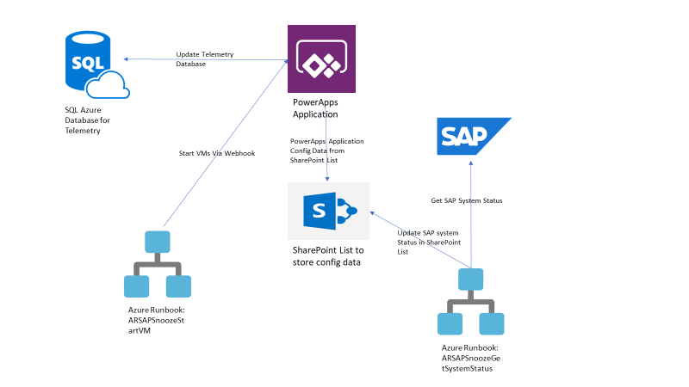

# Setting up Azure runbooks, SQL Azure Tables, Hybrid worker group servers and SAP User account

## Following is the list of runbooks that’re needed:

1. ARSAPSnoozeGetSystemStatus.ps1 – Runbook to get status of SAP systems. This should be scheduled to run every 15 mins.
2. ARSAPSnoozeStartVM.ps1 – Runbook to start VMs. Once this runbook is created, create a webhook and capture the URL.

## Hybrid worker group servers need to have the following modules installed:

* SharePointSDK

Use command Install-Module SharePointSDK -Force to install

## Automation run as account and permissions

An automation run as account needs to be created that has permission to start the VMs

## Telemetry/Usage statistics

A SQL Azure table with the following structure needs to be created to capture usage statics of the PowerApps application. PowerApps would log the details each time a user logs in or start/stop/extend a system.

CREATE TABLE [dbo].[UserTelemetry](

[Timestamp] [datetime] NOT NULL,

[Name] [varchar](256) NOT NULL,

[Email] [varchar](256) NOT NULL,

[System_SID] [varchar](10) NULL,

[Action] [varchar](256) NULL,

CONSTRAINT [PK_UserTelemetry] PRIMARY KEY CLUSTERED

(

[Timestamp] ASC,

[Name] ASC,

[Email] ASC

)WITH (STATISTICS_NORECOMPUTE = OFF, IGNORE_DUP_KEY = OFF) ON [PRIMARY]

) ON [PRIMARY]

GO

TimeStamp – Timestamp of the entry

Name – Name of the user

Email – Email address of the user

Action – Action by the user (Login/Start/Stop/Extend)

# SharePoint List

## SharePoint List properties

A SharePoint list with the following columns needs to be created for maintain system information for PowerApps application.

* Title – Title of the application. PowerApps application landing page will group the systems according to their application.
* SID – SAP System ID
* ResourceGroupName – Azure resource group that hosts the virtual machines for the SAP system
* Status – Status of the SAP system. Allowed values are (Online, Offline, Unknown, Starting)
* SAPStatus – Status of the SAP system
* VMStatus – Status of virtual machines in Azure
* User – Email address of the user who started the system
* MESSAGESERVERHOST – Message server host name of the SAP system
* MESSAGESERVERPORT – Message server port of the SAP system (36XX)
* MESSAGESERVERHTTPPORT – Message server HTTP port of the SAP system (81XX)
* GWSERV – Gateway port of the SAP system (33XX)

## How to onboard a new system on the application

Fill the following details for the SAP system in the SharePoint list

Title, SID, ResourceGroupName, MESSAGESERVERHOST, MESSAGESERVERPORT, MESSAGESERVERHTTPPORT, GWSERV

## SharePoint List permissions

Users who will be accessing the PowerApps application need edit access on the SharePoint list. This can be granted by an active directory security group.

The active directory user that’s used by the Azure runbooks should have edit access on the SharePoint list.

# Creating PowerApps application

## Create PowerApps Connectors

Create a new Connection for SharePoint. Use the credentials of a user who has read and write permissions on the SharePoint List that you’ve created in the above step

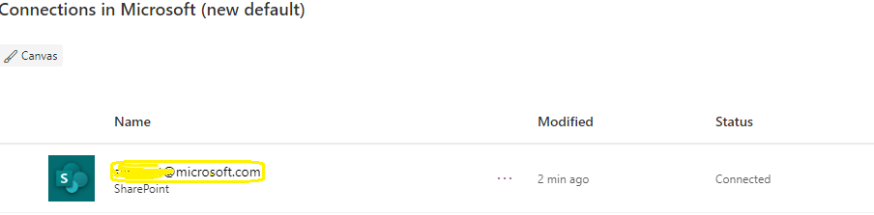

Create a new custom connector “Start SAP Systems” using the json file under /PowerApps/Start-SAP-Systems.swagger.json

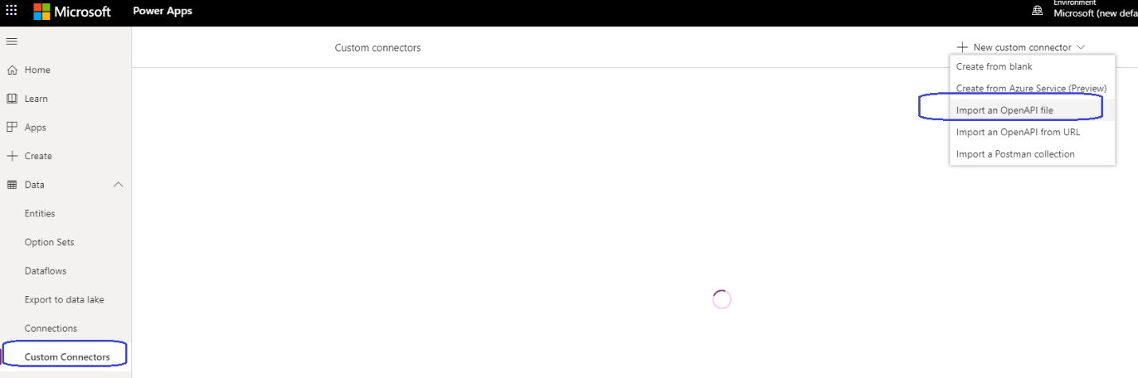

Create the following connection using the newly created custom connector

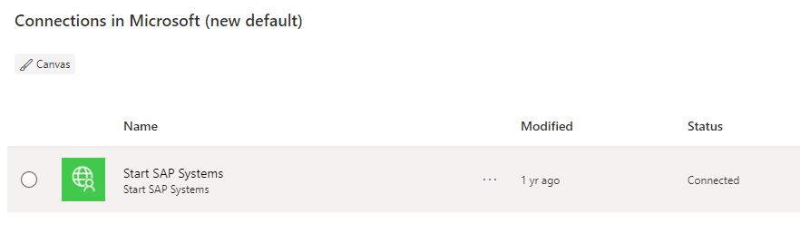

Create a new SQL Server Connection (choose the name appropriately) for collecting usage telemetry

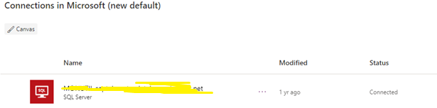

Once the connectors are created, then follow the below steps import the PowerApps package from \PowerApps\SAPSnooze.zip to create the application:

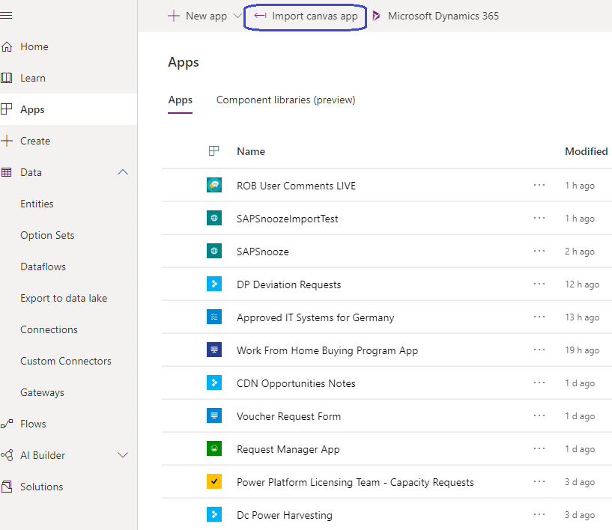

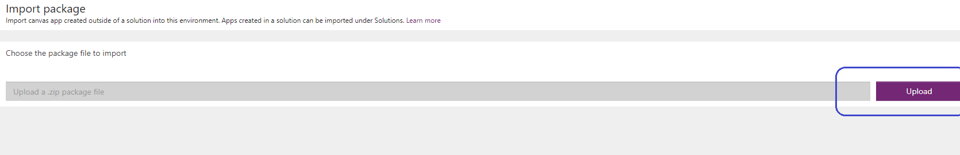

Click on the Action button to select the name of application and connectors and then click on import to finish importing the application.

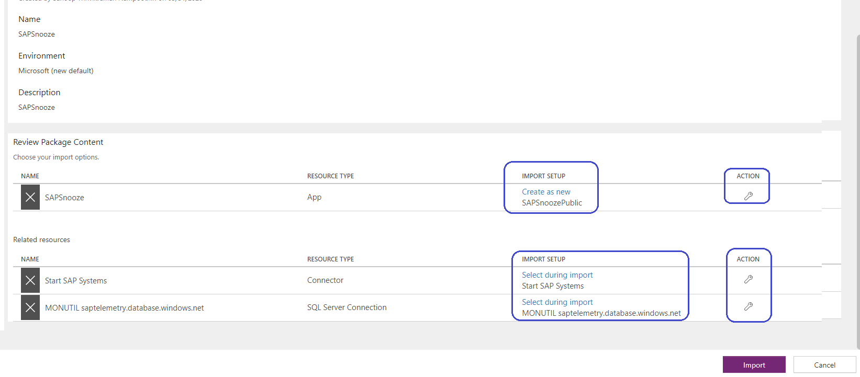

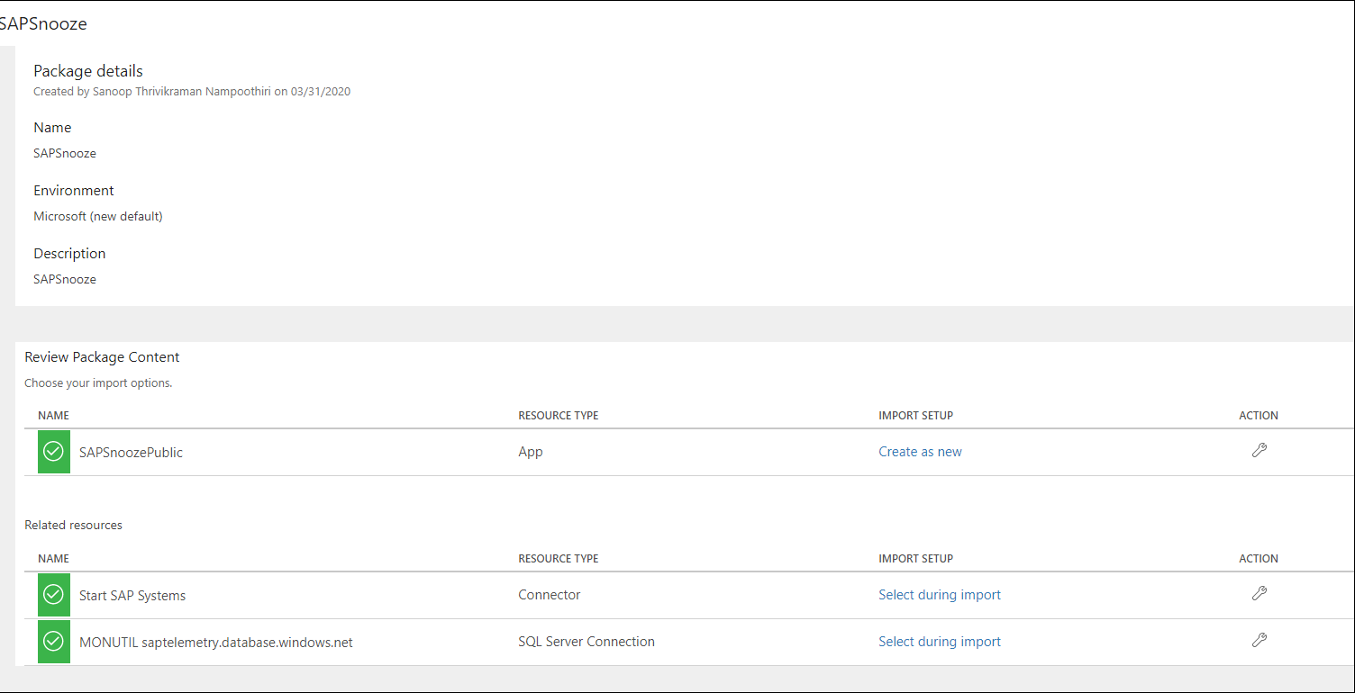

## Update configuration

Once created, edit the application in PowerApps studio, go to “Start” button function and update the web hook token that you’ve created in the step to setup Azure runbooks.

Similarly, update telemetry database table also, in the “Start” button function and in the App lan

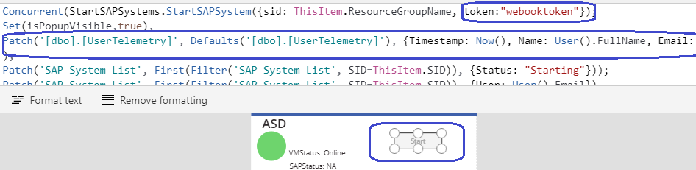

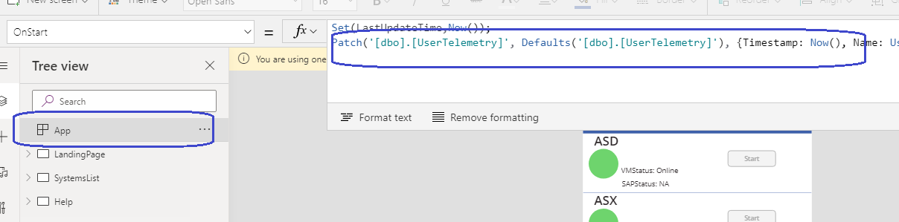

## Permission

Permission to PowerApps can be given to individual users or using active directory security groups. Please note people who’ve been access to PowerApps application should also be given edit access to the SharePoint list that’s created in the previous step.

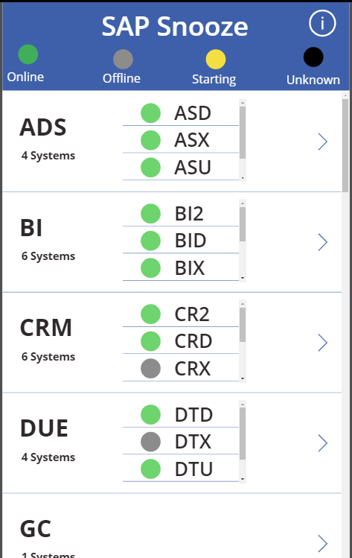

# Appendix